Q1.
Clothes
What is María José wearing?
• una bufanda larga
• una corbata rosa
• un par de zapatos
• una camisa blanca
• una falda nueva

Put a cross in the four correct boxes.
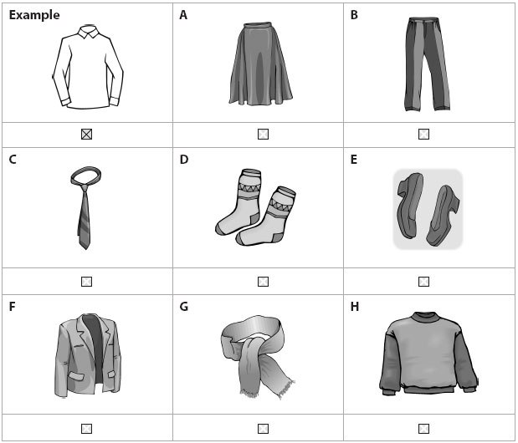
(Total for question = 4 marks)

Q2.
Presents
What presents do they buy?
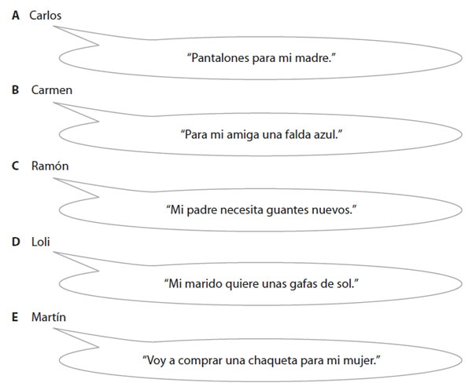
Put a cross in the correct box.

 | A  Carlos | B  Carmen | C  Ramón | D  Loli | E  Martín
Example: Trousers
(i) Sunglasses
(ii) Gloves
(iii) Jacket
(iv) Skirt
( Total for Question = 4 marks)

Q3.
Shopping for souvenirs
Read this shopping list.
• Camiseta
• Postal
• Monedero
• Guitarra
• Sandalias
What are you going to buy?
Put a cross in the correct four boxes.
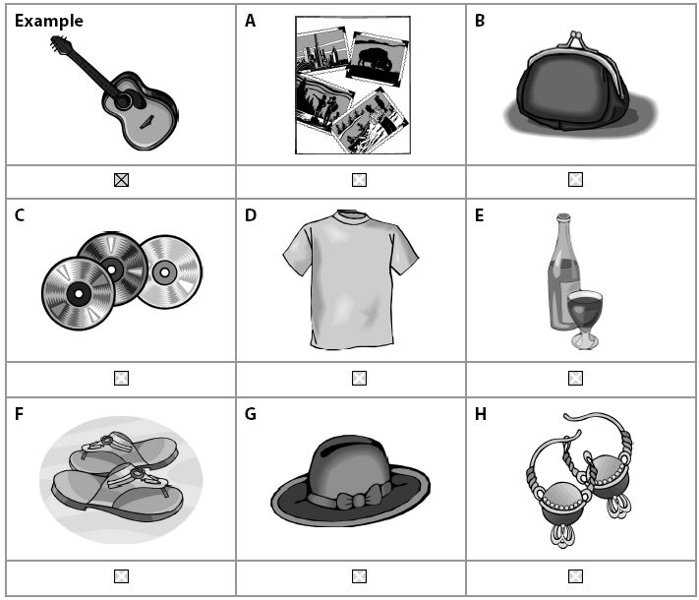
(Total for Question = 4 marks)

Examiner's Report

Q1.
This question was generally well done by most students. Some students failed to recognize 'bufanda' and 'corbata'.

Q2.
This question was generally well done by most candidates and gave the true F and G candidates an opportunity to score good marks.

Q3.
This question was generally well done by all candidates. Some difficulties occurred with 'monedero' and 'camiseta'.

Mark Scheme
Q1.
Question  Number | Answer | Mark
 | Cross boxes A, C, E, F | (4)

Q2.
 | Acceptable Answers | Mark
 | A,C,E,G | 4

Q3.
 | Answer | Mark
(i) | D | (1)
(ii) | C | (1)
(iii) | E | (1)
(iv) | B | (1)

Q4.
Question  Number | Answer | Mark
 | Cross boxes D, A, B, F | (4)

